DAY 26 – 16.05.2024 – OUTPUTSCREENSHOTS

BEFORE LOGIN

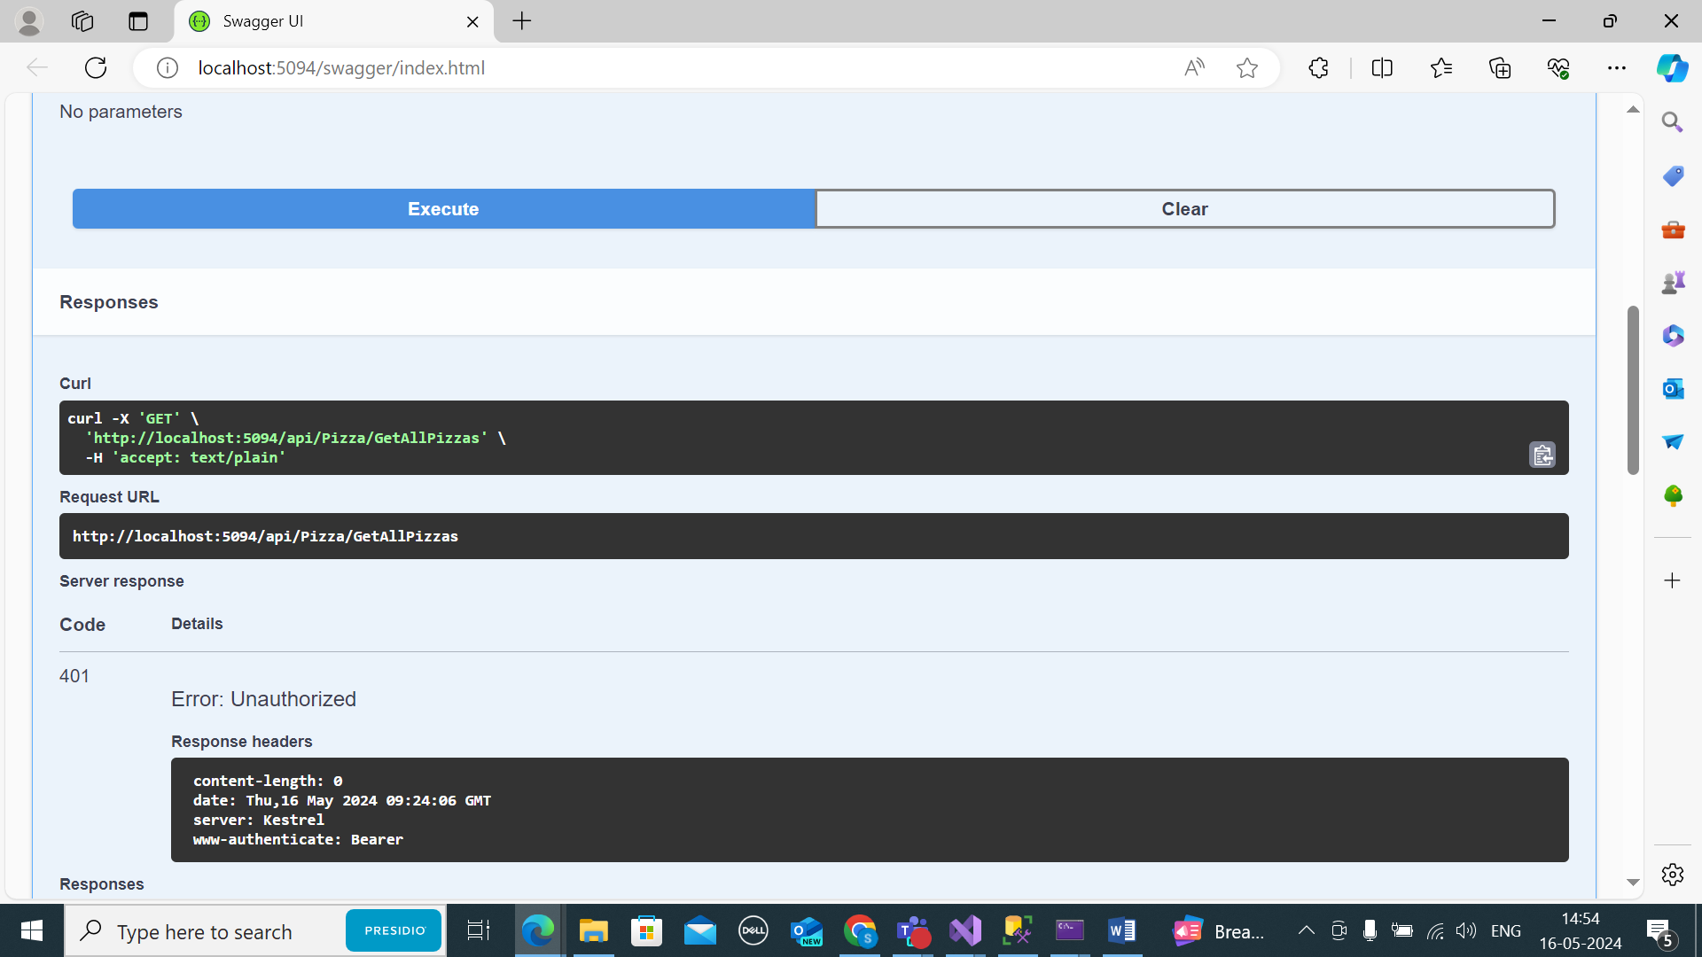

AFTER LOGIN

